The Statistician (1987) 36, pp. 397-408
Good statistical practice
D. A. PREECE
Institute of Horticultural Research, East Mailing, Maidstone, Kent, ME 19 6BJ, U.K.
Abstract. 'Good practice' has a place throughout applied statistical work, and involves the habitual taking of reasonable precautions against mistakes and misunderstandings. The procedures of good statistical practice are founded on experience and commonsense. The time and effort that they require are well spent. Although comprehensive Codes of good statistical practice might be too cumbersome to be useful, specific procedures can readily be described and statisticians should be trained in them. Checking is a key element of statistical good practice. Also, the practitioner should aim to be proficient in writing clear prose, in drawing clear diagrams, and in producing numerical tables that tell their story clearly.
Anacrusis
In a previous paper (Preece, 1986, p. 43) I made a bold assertion about good statistical practice:
"At its simplest, of course, good practice is what I approve of, and bad practice is what / disapprove of! But we all know that a more objective specification is possible, based on clearly statable general principles—even if one of them is commonsense."
Phrases like 'we all know that...' are easy enough to write; now I must see if it can be justified here!
Introduction
The word 'practice' has various meanings; here are the main ones, roughly as in Chambers's Twentieth Century Dictionary.—
• action, performance;
• actual doing;
• proceeding;
• habitual action;
• custom;
• legal procedure;
• repeated performance as a means of gaining skill;
• form so acquired;
• the exercise of a profession
• a professional man's business.
All these meanings are concepts of doing something, and many are of continuing to do, whether the continuation is from habit or duty. Statistical good practice is concerned with 'practice' as 'habitual action', as in
"It is good practice to stop to think before doing a multiple regression analysis."

The notion of habit or routine or established procedure is indeed part of the usual meaning of 'practice', as in
"It is our practice to telephone farmers before we call on them with our questionnaires."
This last example suggests that bad practice may consist of habitually or customarily not doing something-^not telephoning, for example. Likewise, good practice may require omission rather than emission — for example, not soliciting irrelevant detail on a questionnaire. 'Common practice' may be good or bad, as in
"It is now common practice to attach lightning-protection devices to electronic computers."
or
"It is common practice to teach analysis of variance to students incapable of understanding the statistical assumptions associated with the technique."
Although the 'practice' in my title is not 'repetition as a means of gaining skill' (as in piano-practice), the two meanings are connected, as can be seen from the ambiguous sentence
"Good practice in the classroom is good practice for the outside world."
This can mean either that what is good practice in class is also good practice outside, or that to follow good practice in class provides good training for the wider world. The ambiguity with the noun 'practice' arises also with the verb 'practise' — which need not surprise us if we note the similar ambiguity with the verb 'rehearse'. To rehearse a symphony is to practise it; to rehearse the arguments for and against the angular transformation
y=sin^-1*p^(0,5)
is to set them out — like they perhaps never have been! This paper aims to rehearse some of the hallmarks of good statistical practice, to stimulate a discussion of them, and to encourage more training in procedures of good practice — which is neglected in current statistical teaching.
'Reasonable precautions'
'Good practice' is something less than correctness of procedure, something less than a set of essential steps to be taken. True, we can speak of 'correct practice' or of the correct practice in certain circumstances. But this is to imply that a Code of Practice has been set up, whereas much of Good Practice in statistics has not been codified— perhaps because the fields of application of statistics are so many and so varied; perhaps comprehensive Codes of good statistical practice would be too cumbersome to be useful. (A 'Code of Practice', without the adjective 'Good', is something different, concerned with morality, remuneration, restrictive practice, etc.).
Good practice is the taking of 'reasonable precautions': precautions based on experience (whether someone else's or one's own); precautions against misconceptions, misunderstandings, misrepresentations, misformulations, mistakes; precautions requiring time and effort, sure, but time and effort that will be well spent.
Beyond statistics, good practice has a place within a whole range of professional activities: scientific, artistic, commercial, sporting, political, journalistic. Within applied statistics, good practice has a place both in our dealings with people (colleagues and clients) and in our handling of data and computers.

Good statistical practice is well worth writing about and talking about—particularly for the benefit of students and those statisticians who find themselves the only statistician of their firm or institution, those who have never had the good fortune to work alongside an experienced wise statistician in a group or team, those with more knowledge of the mathematical theory of statistics than of how to apply and modify that theory in practice.
The statistician's role
In scientific and technological research and development, the statistician's role is ideally that of a colleague, a collaborator, a member of a research or development team, not that of a supernumerary consultant called in only for pronouncements on design and analysis and for computational facilities (see Yates, 1946, paragraph 5). This is not to say that the statistician should have a big role in every project or that he should poke his nose into all aspects of what everyone else is doing. But it is to say that he should have an intelligent awareness of the aims and objectives of a project, from as close to its inception as possible, a lively awareness of all its quantitative aspects, and a sufficiently close involvement with other members of the team that he has ample opportunity to contribute informed thoughts on how to use available resources as efficiently as possible to obtain sufficiently precise results. So good practice has a place in organisational matters; it requires a statistician to work up good relationships with his colleagues and to make himself available even at times when nobody has a specific job to give him to do.
My own applied statistical work has mostly involved comparative experiments in agricultural research. In this sort of work, many statisticians have devoted most or all of their effort to individual experiments, to the exclusion of planned series of similar experiments and to the exclusion of the planning of coherent projects and programmes. The bulk of statistical textbooks on comparative experimentation reflect this emphasis—perhaps dictate it. By contrast, it is good practice for the statistician to think more widely than of just the individual experiment—whatever the other research planners may think of his role.
It hardly needs a statistician to fault the setting-up of a three-year project to study a
five-course agricultural rotation where each course lasts a year. Yet such 'projects' can well emerge from a 3-year funding system for aid to developing countries. Likewise,
now that farming systems are a fashionable concern, people can be sent to countries
previously unknown to them on 3-year assignments to identify new improved farming
systems. Here again, a statistician is hardly needed to point out that a 3-year
agricultural assignment overseas can usually encompass no more than 2 years of
experimentation, and that 2 or 3 years of results and observations obtained by an
expatriate are no reliable basis for overturning established practices of farmers who,
with their forebearers, may have been farming their land for generations and have
accumulated great experience of problems that might well not show up in 2 or 3
consecutive years. But in such contexts—and in less absurd ones—the experienced
statistician ought to be able to talk helpfully about year-to-year variability in crop
yield, about inherent confounding of factors influencing production, and so on.
Planning and design of experiments
I once visited a forestry experiment on some sloping land in West Africa. When I
commented that the experimental design seemed not to marry up with the slope, I was
told: "Ah well, this experiment was designed in Rome!" Whether it can ever be good.

practice to design experiments so remotely is, I suggest, not quite a straightforward matter.
Suppose a co-ordinated series of field experiments is to be run, with many sites in each of several years, and with the same treatments at each site. A statistician is unlikely to be able to visit all these sites in every year—and he probably need not do so. Experimental designs for this sort of work should be simple, with properly trained field officers left to lay but the plots. But even to have the same treatments with the same replication at each site is not—for example—to require any blocks in the design to be of the same shape or in the same orientation at each site. To specify the treatments and the replication in Rome (or at, say, Rothamsted or East Mailing) is one thing; but to draw a field plan there, with measurements, and to insist on this plan being followed exactly at every site is another.
Each trial of the series needs its own randomisation, of course, and workers must understand that. It is also desirable that supervisory workers should understand what blocking is about. Good practice requires us to stress repeatedly that blocking in field trials has two roles: firstly to pick up appreciable components of variability in the land or environment, and secondly a management role (Dyke, 1974, pp. 42-43) or administrative role (Pearce, 1983, pp. 42-43). In this second role, blocks can pick up appreciable unwanted components of variability introduced by the way in which the experiment is run. Thus many field operations on the whole experiment—operations such as scoring, weeding and harvesting—should usually be done by blocks, to pick up temporal differences or differences between workers.
Mention of randomisation of field trials leads to the more general point that it is good practice for a statistician to try to check whether his scientific colleagues and clients understand randomisation and statistical randomness. In recent years I have advised several research scientists who did not understand. One had allocated treatments systematically and thought this was 'much the same' as randomly, although this was clearly not true in that instance; another thought that an allocation was random if produced haphazardly out of his head! Sadly, readers and referees of technical papers must be prepared to be sceptical even about statements that a design had randomised blocks. But we should not be harsh in blaming research scientists for this state of affairs: it was statisticians who hijacked the English word 'random' and gave it a narrow specialised meaning, and statisticians are often poor at explaining themselves.
In more general matters of planning and design, good practice may often require a statistician to consider various practical matters such as the recruitment, training and management of field staff. The mention above of the desirability of doing management work 'by blocks' in experiments is just one reminder that people, by what they do, can introduce variability into data, and that we want to keep this under control. Staff who are bad at reading scales on balances can introduce unnecessary variability; amazingly many such people cannot produce readings to a consistent degree of precision of recording (for example, recording all of a set of weights to the nearest multiple of 5 kg) and know neither the word 'parallax' nor the concept (let alone its spelling!). I do not recall parallax being mentioned in any statistics textbook, yet the concept can be so much more important in practice than textbook favourites such as 'kurtosis'. It is good practice for statistics lecturers to check whether their students know how parallax can distort scale-readings taken by someone not viewing the scale at right angles.
Generalising from balances, it may often be good practice, at the planning stage, to think ahead to whether adequate instrumentation is available for recording the required data to a sufficient degree of precision. (Statistics teaching should stress that data commonly come from man-made instruments, not from tablets on Mount Sinai.) Advance thinking about the format and content of data-sheets, if such are to be used, is good practice too; recording data on odd scraps of paper and backs of envelopes is bad practice.

The handling of data
Good practice in data-handling is another matter to be stressed in statistics teaching. Students should know that avoidable copying of data is bad practice as copying—like other human activities—produces errors. Students should also know about checking copied (including typed) daja by calling-over, and about checking the keying-in of data to a computer. (One method for the latter is the sort of verifying that requires retyping, by someone else, so that the machine can compare the two typed versions and display any discrepancies.)
Data scrutiny
The scrutiny or sniffing-over of data has received much attention from statisticians in recent years. On the one hand there is the ever-continuing work on diagnostics (including detection of outliers); on the other we have E.D.A. (Tukey, 1977) and IDA (Chatfield, 1985). How much of this we should use is very much a question of good practice. Much data nowadays gets pushed through statistical analyses before anyone has looked at it. This can readily happen to data entered directly into a computer system. (Recording is increasingly being done by machine, not man.) But it also happens all too often with manually recorded data. Many research scientists seem to have distressingly little inclination to look at their data — even though some of these people are wcjnt to make their own attempts at moderately elaborate statistical analyses. All too often the researcher presents himself to the statistician or computer with the words "Here are my data. Please analyse.", and seems to suppose that this is his sole duty towards the data until the scientific paper or technical report is written. In some routine applications this may be all very well and not bad practice, but in much research this is the scientist abdicating his scientific responsibilities and settling for the quiet life of pseudo-scientific ritual.
The computer can of course be used to help with data scrutiny. But even here there are dangers. The computer might, for example, give us a scatter diagram such as that

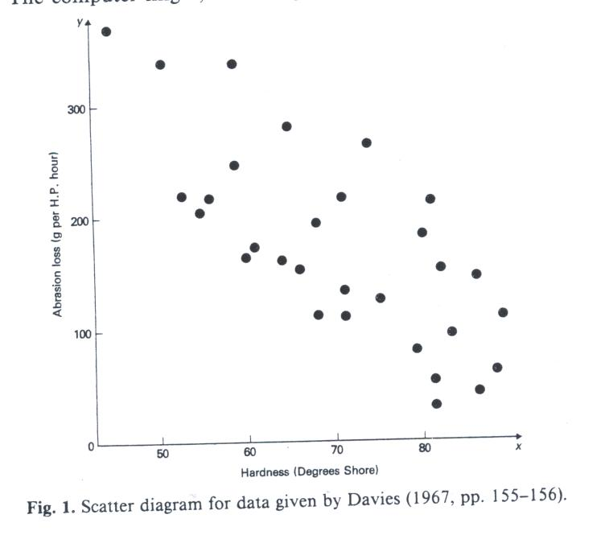

in Fig. 1, which is for a well-known set of data given by Davies (1967, pp. 155-156). However, if we ourselves had plotted the points on graph-paper (do you remember graph-paper, dear reader?) and plotted them in the order in which they appear in the data-table, we would have found what is illustrated in Fig. 2, where the points denoted 1 were plotted first, then the 2's, then the 3's, and so on. Proper interpretation of the data is impossible frorn Fig. 1; the order of the data clearly needs to be taken into account, although we have insufficient information to say how it should be allowed for.

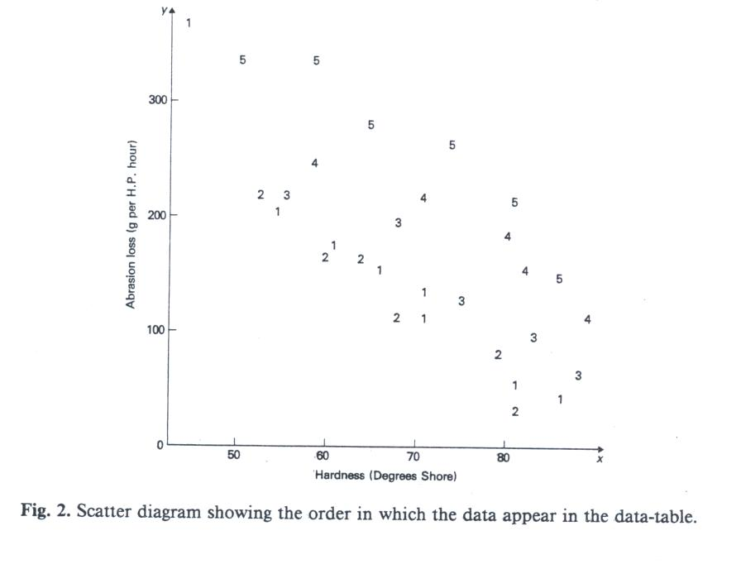

Analysis and computation
In statistical analysis and computation, checking must again be to the fore in good practice:—
• Checking that the data are the right data and in the right order.
• Checking that the design information accompanying the data is self-consistent and—as far as one can tell—consistent with good design.
• Checking that the pocket-calculator to be used does its calculations with the
expected computational logic. « Checking that the precision of the arithmetic of calculator or computer is adequate;
checking that the programmer has not used a procedure or algorithm that leads to
computational disaster. « Checking that the programmer has not misunderstood a method of analysis;
checking that it wasn't the wrong method anyway.
• Checking that what the program does or tries to do is what the documentation
claims it does. » Checking that analyses at least look plausible in the sense of producing quantities of
the right order of magnitude.
• Checking specific values of derived variates to be sure that the derivation formulae were correct.

Of course, not all these checks are needed every time. But good practice requires a readiness to make them, so as to take the 'reasonable precautions' discussed above.
Most of us would describe it as common knowledge or commonsense that the worst method of checking calculations is to repeat them in the same way. Even simple addition of a column of figures is better checked by adding them in a different order—say from bottom to ^op if we started at the top the first time. If marginal totals are to be attached to a 2-way table, each margin (i.e. the right-hand margin and the bottom margin) should be summed, to provide the check that the two grand totals are the same. This too needs to be pointed out to students. I disagree with the notion that a student should check his calculations by seeing if he gets the same answer as the next guy does; to allow people to slip into this sort of checking is bad practice.
Output from statistical programs and packages
Now I turn to good practice in what is printed in computer output produced by statistical programs and packages.
Except in restricted packages to be used only by small groups of people, great caution is needed in what is printed. The big packages are being used by whole hosts of people, many of whom have a very wonky statistical understanding. Indeed Genstat, so long said to be inaccessible to non-statisticians, is now used by many such people. (There will be many more, as Genstat 5 becomes available.) Of these, not a few will specify analyses incorrectly. But correct specifications will be made too, and then the users deserve due protection from risk of misinterpreting their output.

Optional output
The output from programs and packages may suffer defects of either omission or commission. A notable defect of commission is made by those regression programs that print a Durbin-Watson statistic with every regression analysis, irrespective of whether there might be a temporal sequence—or indeed any other sort of order—to the observations. What is the uninitiated innocent to make of this statistic in his output? He may waste time unnecessarily in discovering what it means—or would mean, if it were relevant. Equally he may suppose that it must be important (since the program has troubled to provide it), may be too lazy or too buzy to find out its meaning, and so may copy it into the text or tables of his published scientific report.
The copying of ill-comprehended output is well illustrated by the way in which some Reports from overseas agricultural research institutes have given coefficients of variation (C.V.s) for every variate analysed, irrespective of whether the variates were yields, increments of growth, counts or transformed counts, percentages or transformed percentages, or whatever. This overuse of the C.V. is itself worse than bad practice, as it involves misunderstanding. Because the C.V. is dimensionless, people suppose that it must therefore be an absolute quantity in the sense that, say, a C.V. as large as 20% must always be, in some sense, bad. However, the C.V. is not absolute. For a standard yield variate from a modern British field experiment on a cereal crop, a 20% C.V. would indicate something seriously amiss, but in other applications a 20% C.V. may be about the best that one can hope for. Faced with so many users who do not understand C.V.s, I deem it to be bad practice for a program to print a C.V. automatically with every analysis of variance.
If some components of output are not to appear automatically but only on demand, the program must provide the user with 'options'. Options for printing the Durbin-Watson statistic and the C.V. are simple examples. However, options may well be tiresome or troublesome to program. This is but one of many arguments for leaving statistical programming (other than use of general programs and packages) to specialist teams of people who have the time and expertise to do the job properly and who know that statistical analysis should rise above the level of ritual and mumbo-jumbo.
'Sig. figs' in output
Also to be condemned in so much statistical computer output is the printing of means, standard errors, sums of squares, means squares, variance ratios, r-values, etc. with inappropriate numbers of significant figures, e.g. a regression coefficient with 13 'sig. figs' or a f-value with 6 decimal places. The numbers of 'sig. figs' from some packages are wildly inappropriate, making the output hard to read and encouraging people to believe in spurious precision.
Bad practice shades into error when meaningful terminal zeros are suppressed in a number containing a decimal point. The meaning of 3-70 is different from that of 3-7, as we were all (I hope) taught long ago, and the distinction is too important to be ignored in the displays of pocket calculators and in computer output on paper. The problem arises because some programmers have decided to suppress all terminal zeros rather than tell the machine how to decide whether particular terminal zeros are meaningful or not. It is indeed undesirable for the minimum aphid count per leaf throughout 48 apple-leaves to be printed as 3-0000, or for the average of a pair of counts to appear as 5-5000 (or even 5-4999). But here the machine needs to be told that the data were integers and to be furnished with a few simple rules for printing or displaying quantities derived from integers; automatic suppression of terminal zeros is the wrong answer to the problem. With current computing sophistication, why can we not make the effort to tell computers about integers and about the degree of precision of data and of quantities calculated from them? Future 'intelligent' statistical computer-programs will indeed have to go further by distinguishing, for example, between counts and integer scores, and between measurements with a natural origin (e.g. lengths in centimetres) and those with an arbitrary origin (e.g. temperatures in Fahrenheit or Celsius).

Output containing analysis of variance tables
Now to something deeper. Some years ago there was rightly a great hoo-ha when people found that different regression and analysis-of-variance packages produced numerically different analyses of variance for non-orthogonal models. Part of the problem was computational. But the part that especially concerns good statistical practice derives from poor labelling of computer-output and from the fact that there is no unique analysis of variance for a non-orthogonal model. This fact should have been clear to everyone concerned ever since—at the latest—the appearance of Dr Frank Yates's paper (Yates, 1940) on the recovery of interblock information in balanced incomplete block designs; Table 1 of that paper sets out two different partitions of the total sum of squares, side by side. However, the different partitions for a non-orthogonal model are still widely not understood; that different partitions are possible is a mystery to biological researchers familiar with analysis of variance only as an adjunct to the randomised complete block design!

The point is this. If we have two non-orthogonal model-factors A and B, we can first calculate a sum of squares for A ignoring B (i.e. for A when B is absent from the model), and then a sum of squares for B eliminating A (i.e. the additional sum of squares accounted for when B is introduced into a model already containing A); alternatively we can take B ignoring A, then A eliminating B. In general the sum of squares for A ignoring B is not equal to that for A eliminating B. So to print something merely called a 'sum of squares for A' is to invite trouble.

More generally, in an analysis of variance for terms A, B, C,..., the sum of squares for each term may be calculated ignoring all other terms, or eliminating all other terms, or eliminating all previous terms, or in other ways that might suggest themselves if some terms are interactions of others.

The vocabulary of'ignoring' and 'eliminating' is that of Yates (1940) and has—in my opinion—much to commend it. However, some statisticians now dislike it (one senior colleague of mine regards it as arcane as well as archaic) and prefer to speak of a sum of squares for 'A before fitting B' or 'B after fitting A'. Whichever terminology is preferred should hardly be a matter for quarrels; what is important is that anyone picking up a non-orthogonal analysis of variance can see that the terms are non-orthogonal and can tell what each sum of squares and mean square really is. This does not necessarily mean printing 'before fitting' and 'after fitting' (or 'ignoring' and 'eliminating') in every line. If the analysis is one of those where each sum of squares has been calculated eliminating all previous terms but ignoring all others, then the sequential fitting need merely be stated in a heading. Perhaps alternatively, the successive sources of variation could be printed as A, +B, +C,..., where the + signs denote that the sums of squares are derived by sequential introduction of terms into the model; however, this Genstat notation is not yet known widely enough, for people's understanding of it to be taken for granted. What is not sufficient is to rely on statements in the program manual, which the user of the output may never see.
The printing of standard errors
Interpretation of the results of factorial experiments requires one-way, two-way,..., tables of means, and the appropriate standard errors. Usually, only a few standard errors are needed. For example, many a two-way table of means needs just one standard error for each of its margins and just one—or perhaps two—for the body of the table. Until about 20 years ago there was, I think, a clear convention on where, with respect to the rest of the table, the standard errors should be printed; an example is given in Table 1. But this convention has now been overthrown by various developments:
• the quasi-doctrinal disagreement on whether to print standard errors of means or of
differences between means;
• the increasing production of tables by computer;
• the unreasonable amount of programming effort that would have been needed, in the
early days of statistical programming, to position standard errors centrally whatever the
numbers of levels of the factors;
• the way in which a Genstat anova saves up all its standard errors for printing after the whole
set of tables for a variate;
•the common emphasis on hypothesis-testing, exemplified by the strong lingering
affections that some people still have for least significant differences, and by the mania for multiple-range tests.
Little wonder that scientific authors are now grievously confused about their standard errors and where to put them; many published standard errors are probably not what they are stated to be, and often even a statistical reader cannot deduce what the printed SEs or SEDs are the standard errors of! The requirements of good practice require us to get ourselves out of this mess. But how? An International Standard seems both desirable and unattainable.

Table 1. Table to illustrate layout for standard errors (Yields of grain of beans at 85% dry matter, in cwt per acre)
Treatment  after planting | Initial cultivation
 | P | R | T | Mean
 |  | (±2,57) |  | (±1,48)
M | 39,1 | 27,5 | 31,5 | 32,7
X | 33,8 | 33,9 | 29,7 | 32,4
Y | 33,0 | 32,5 | 34,8 | 33,4
Mean (±1-48) | 35,3 | 31,3 | 32,0 | 32,8

Interpreting and reporting results
Surely no-one can suppose that it is good practice for a statistician to wash his hands of a project as soon as the computational parts of the analysis are complete. Indeed, if the statistician is to be the sort of colleague that I suggested at the start, he should frequently be contributing to the writing-up of the results himself. So it is good practice for him to make himself proficient in:—
• the use of clear, concise prose for quantitative reporting;
• the production of numerical tables that tell their story clearly;
• the drawing of well-labelled, uncluttered, honest diagrams.

Anyone who has regularly refereed quantitative papers for journals of applied science knows that papers come in with graphs whose axes are not labelled and with tables whose headings do not give the units of measurement; in checking a paper, it is good practice to skim through quickly in search of such omissions.

Statisticians have, of course, to concern themselves with written accounts other than those in learned publications. Take, for example, the article 'Soccer under pressure from inflation' in The Times of 3rd August, 1985. This front-page article was not about monetary inflation but about inflated footballs and their bounce. It stated that balls of 17 different makes were bounced and that there were, between makes, 'surprising variations' in height of bounce. Readers were told that, altogether, 1020 balls were bounced. So, as 1020=60x 17, we can reasonably conclude that this was a replicated experiment with exactly 60 balls of each make. What readers were not told included:—
• how many times each ball was bounced;
• the variability of bounce height for each ball or between balls within makes;
• the sampling procedure for the balls of each make;
• whether there were indications of bounce height deteriorating more with some makes than with others.
So we were given 17 means, recorded pictorially as in Fig. 3, but no guide to whether the variation amongst these means was other than random—no guide, that is, apart from our own intuitions and prior knowledge of bouncing footballs. Was this bad practice, in an admittedly light-hearted article? Perhaps we should just be grateful that we were spared the alphabetic outpourings of a Duncan's multiple-range test! Yet perhaps we should feel uncomfortable that the newspaper should have produced a 'Good Story' without any statistical evidence that it was a story at all. If we allow newspapers to ignore statistical argument, we can only expect thoroughly misleading accounts of the results of Opinion Polls.

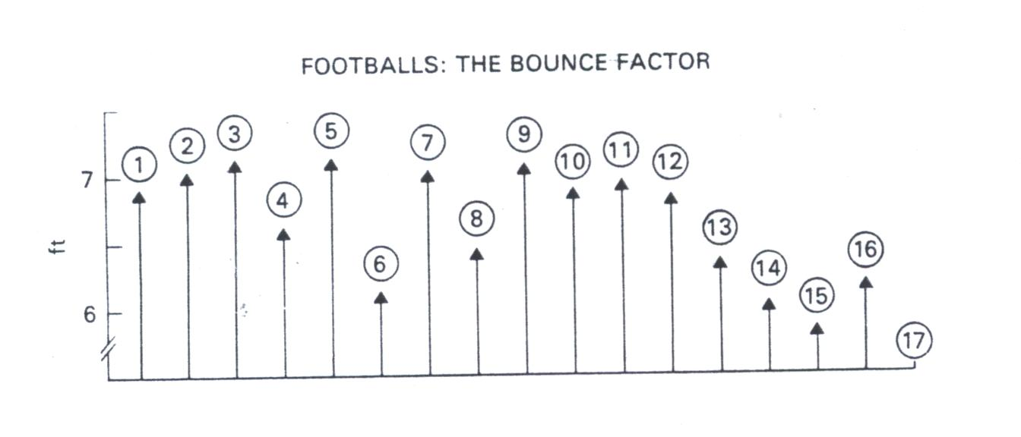
Fig.3. Height of bounce (from 15 ft) for footballs of 17 different makes.

Turning back to scientific journals, we see that the quality of the statistical work varies greatly throughout the literature of quantitative biological and medical research. Even within British research journals, the quality ranges from the very good to the very bad, and this latter includes statistics so erroneous that non-statisticians should immediately be able to recognise it as rubbish. Although some journals have very good practices for trying to ensure the soundness of their published statistical work, others have abdicated or not assumed their responsibilities in the matter, and some actually encourage bad statistics.

Over the past few years, two British journals of agricultural and horticultural research have caught my attention for particularly bad statistical work. Each had a statistician on its Editorial Board, but these statisticians were restricting their attention to specific papers judged to have special biometric content; they were not taking an overview of the state of statistics in their journals as a whole. Good practice seems to me to require such people to take the overview and to report to other Board members on the overall statistical quality. These statistical representatives should of course be carefully chosen people of wide practical experience, so that they can be truly authoritative. They will indeed have to face up to bad statistics not only from authors but also from referees!
Conclusion
This article has roughly followed a line of progress from the planning to writing-up stages of a piece of research or development work. The role envisaged for the statistician in that work admits of good practice throughout. Such good practice involves—amongst other things—true collaboration with others (and therefore courtesy), openmindedness, thinking-ahead, questioning, checking, avoiding the over-simple and the over-elaborate, and explaining things clearly.
Acknowledgements
This article is based on talks given by invitation to the General Applications Section of the Royal Statistical Society (1985) and to an Annual Conference of Statisticians in the Pharmaceutical Industry (1986).
References
chatfield, C. (1985) The initial examination of data (with Discussion), Journal of the Royal Statistical Society, Series A, 148, pp. 214-253.

da vies, O.L. (Ed.) (1967) Statistical Methods in Research and Production, with Special Reference to the Chemical Industry, 3rd edn reprint (London, Oliver & Boyd).

dyke, G.V. (1974) Comparative Experiments with Field Crops (London, Butterworths).

pearce, S.C. (1983) The Agricultural Field Experiment: A Statistical Examination of Theory and Practice (Chichester, John Wiley).

preece, D.A. (1986) Illustrative examples: illustrative of what? The Statistician, 35, pp. 33-44.

tukey, J.W. (1977) Exploratory Data Analysis (Reading, Massachusetts, Addison-Wesley).

yates, F. (1940) The recovery of inter-block information in balanced incomplete block designs, Annals of Eugenics, 10, pp. 317-325. [Reprinted in yates, F. (1970) Experimental Design: Selected Papers,pp. 201-210 (London, Griffin).]

yates, F. (1946) The place of statistics in agricultural research, Agricultural Progress, 21, pp. 40-50.

